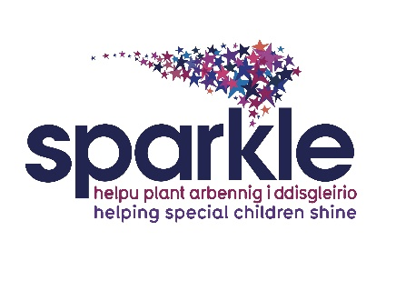

Sports and activities volunteer

Job Description

Post title: Sparkle volunteer

Responsible to: Sparkle Leisure Team Leader

Role Summary
The role of the sports & activities volunteer is to support or assist with sport & activity sessions for children & young people with a disability and/or developmental difficulty providing them with the opportunity to take part in activities, meet new people and develop skills.

Key Tasks
These include but are not exclusive to:
- Engage and play with the children and young people accessing Sparkle leisure activities
- Help setting up, cleaning & putting away equipment
- Deliver or help deliver aspects within the leisure activities
- Liaise with other personnel including volunteers, support workers, parents, Sparkle staff & centre staff
- Attend any training required
- Report any concerns or issues to the Sparkle Leisure Team Leader
- Act in a professional manner at all times whilst delivering a high level of customer service
- Adhere to all health & safety guidelines & Sparkle policies
- Make things FUN!

Person Specification
We are looking for volunteers who:
- Are passionate about supporting children/young people with disabilities and/or developmental difficulties
- Adopt a friendly, happy, welcoming approach
- Have an ability to engage with people of all ages and abilities
- Are reliable & punctual
- Are organised and have effective time management
- Are outgoing, personable and a good conversationalist
- Are able to adapt quickly and flexibly to situations to ensure the smooth
- running of sessions should unexpected events occur
- Have good listening skills
- Display honesty and integrity
- Show compassion and empathy as the situation requires
- Have the ability to make people feel at ease
- Present with a smart, neat appearance and professional demeanour
- Are polite and courteous at all times, regardless of the situation
- Are willing to go the extra mile, even at busy times
- Can offer a regular time commitment

Management Responsibilities
No management responsibilities

Responsible to
Sparkle Leisure Team Leader

Special Conditions
This job requires a satisfactory DBS check, children barred list check and occupational health check. Two satisfactory references are also required as is proof of identification and authorisation to work in the UK.
Disclosure and Barring Service check
This post will result in you having substantial contact with children. By virtue of the Rehabilitation of Offenders Act 1974 (Exceptions) Order 1975, the Children’s Act 1989 and/or the Police Act 1997, you are required to reveal any criminal convictions, bind over orders or cautions, including those which would normally be regarded as spent. You must complete the relevant section on the application form – your application will be returned if this section is incomplete. If successful in your application you will subject to a Disclosure and Barring check to include the children barred list check.

