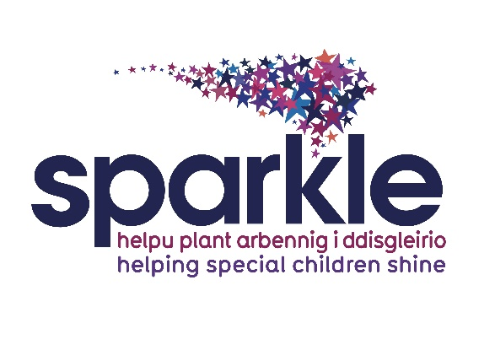

**Q&A**

**Why is there a need for a mandatory annual fee?**

The fee is intended to cover the costs of providing specialised equipment, trained staff, and accessible facilities to ensure that children, young people and families can fully experience leisure services. We are a charity and as such receive no income from Welsh Government or public bodies. We do receive grant contributions from a minority of Gwent Local Authorities.

***Our predicted income this year (24/25) is £500k but our outgoings are expected to be £800k, leaving a shortfall of £300k (60% of our income)***

**How does the fee support the running of clubs and the future of the charity?**

In line with most local organisations providing leisure activities for our children and young people (CYP) the introduction of the annual fee helps ensure that clubs have the necessary resources to operate effectively, including funding for staff, equipment, and facilities. It also contributes to the long-term sustainability of the charity, allowing it to continue offering valuable services and expanding its reach to more children in need.

***The mandatory annual fee will bring in an income of £29k. This contribution to our costs will reduce our shortfall this year to £271k. However, this amount still only covers less than 10% of our deficit, further action is ongoing to try to close this gap***

**Are there any exemptions or discounts available?**

**How can parents apply for financial assistance?**

Yes, there may be exemptions or discounts for families with financial hardships.

The hardship fund is available to access for families who may find themselves unable to pay **all or part of the annual fee**. Please contact us to discuss if you need financial help, we want to support all our CYP to be able to access our services. Please see the attached hardship policy.

If families **only** wish to be registered for MediCinema, and no other family/child activities, this fee does not apply, as per MediCinema charity registration.

**What leisure services does the fee apply to?**

The fee covers all Sparkle leisure services, including family activities e.g., family swim, family events, private bookings, holiday activities, all clubs, and swimming lessons.

If your CYP is on the waiting list, then the fee will apply as your CYP is entitled to access all our family activities, and ‘waiting list’ children are also offered places on our Holiday Activities before those children who are already accessing a regular club.

However, if a family only wishes to access MediCinema and no other family/child activities, this fee does not apply, as per MediCinema charitable registration.

**Will the fee affect the quality of services provided?**

The introduction of the annual fee will provide a vital income stream for Sparkle.

Grant income for all charities has been extremely difficult to access over the last few years. As a charity we work hard to fund raise and to identify grant opportunities. The grant process involves much work, for example, submitting paperwork; gathering evidence; undertaking research and providing reports etc.

***Last year (2034/24) we submitted 47 grant applications to trusts and foundations (not including local authority grants) with a 38% success rate.***

***So far, this financial year (2024/25), we have received nearly £240k in grant income; this includes income from multi-year grants, grants we have secured from local authorities, and £84,557 from 16 new successful applications.***

Our goal is to enhance the quality of services by ensuring that there are sufficient resources to meet the needs of our families. Our staff receive extensive training, paid for by Sparkle, and are expert in this field of leisure work. This training directly underpins the quality of our services. The annual fee will directly support the delivery of leisure services and help to secure the future of the charity.

We also work hard fund raising throughout the year.

***So far this year fund raising has raised £124k***

**My child’s club is grant-funded, do I still need to pay the fee?**

Grant funding does not fully cover the cost of delivering our specialist leisure clubs, as many grants will not fund essential elements such as insurance, venue costs, software, administration, recruitment checks, training, uniform, audits and governance.

***Last year (2023/24) it cost £787k to deliver all our services, however our grant income only covered 40% of these costs.***

**Is this fee refundable, if we no longer wish to access Sparkle leisure services?**

This fee is non-refundable due to increasing overhead costs and is essential for the survival of the charity.

**What if a child/young person is unable to attend activities?**

The fee is typically structured to cover the entire year, regardless of the number of activities attended.

**How will annual club reallocation effect this fee?**

The annual reallocation of clubs will not affect the fee, as this fee remains mandatory for all families registered to leisure activities and/or on a waiting list.

**Is this fee still required if we are already paying for club sessions or family activities?**

Yes, the fee is required over and above the club or family activity costs, to enable us to continue providing our vital services.

**How can parents provide feedback or raise concerns?**

Parents can provide feedback or raise concerns by contacting us directly or by using Sparkle’s Putting Things Right Policy. We are always happy to meet to discuss any particular issues.