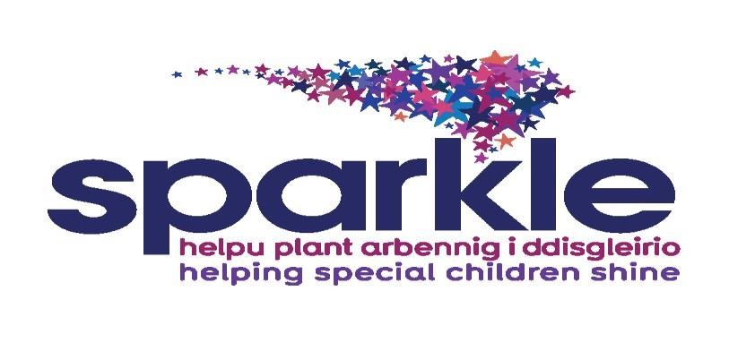

**Sparkle Safeguarding and**

**Child Protection Policy and Procedures**

Review date: September 2024

Reviewers: Rebecca McDonald, Sabine Maguire and Tracey Pead

Date for review: September 2025

**Contents**

|  |  |
| --- | --- |
| **1. Introduction and purpose** | **3** |
| **2. Scope** | **3** |
| **3. Aims** | **3** |
| **4. Definitions** | **6** |
| **5. Principles** | **7** |
| **6. Responsibility- trustees** | **9** |
| **7. Responsibilities- staff** | **11** |
| **8. Related policies and procedures** | **12** |
| **Appendix** | **13** |

1. **Introduction and purpose** 
   1. Everyone has a role to play in safeguarding and protecting children, regardless of the type or amount of contact they have with children.
   2. Children and young people who come into contact with Sparkle as a result of our activities must be safeguarded to the maximum possible extent from deliberate or inadvertent actions and failings that place them at risk of child abuse, neglect, sexual exploitation, injury and any other harm.
   3. The purpose of this policy is:
   4. To protect children and young people who receive Sparkle services and also any child/young person Sparkle comes into contact with at the centres, including concerns about children/young people where their parents/carers are in receipt of Sparkle services;
   5. To provide staff, trustees and volunteers with the required safeguarding principles and procedures for the safeguarding of children / young people.
2. **Scope** 
   1. This policy applies to all staff, trustees, volunteers or anyone working on behalf of Sparkle.
   2. Everyone must:

* Recognise the signs of potential child abuse;
* Act promptly when safeguarding concerns arise and follow the correct referral process (Appendix 2), including the flowchart in Appendix 4;
* Understand what Sparkle expects of them in terms of their own behaviour;
* Know how to prevent harm to children;
* Learn about child protection issues in accordance with the relevant statutory guidance and within the context of their own roles and responsibilities;

1. **Aims** 
   1. Sparkle believes that a child or young person should never experience maltreatment of any kind. We have a responsibility to promote the welfare of all children and young people and to keep them safe. We are committed to practice in a way that protects them.
   2. Research shows that disabled children are three times more likely to be abused than non-disabled children (<https://publications.aap.org/pediatrics/article/147/5/e2021050920/180813/Maltreatment-of-Children-With-Disabilities>)
   3. Disabled children at greatest risk of abuse are those with behaviour/conduct disorders. Other high-risk groups include children with learning difficulties/ disabilities, deaf children, children with speech and language difficulties, emotional/behavioural disorders and children with health-related conditions.
   4. Factors that increase risk and lessen protection include:

* Attitudes and assumptions that do not treat disabled children equally and have an impact on all aspects of their lives – reluctance to believe disabled children are abused, minimising the impact of maltreatment and mistakenly attributing indicators of abuse to a child’s impairment;
* Barriers to the provision of support services that lead to the disabled child and their family being isolated, lacking a support network;
* Unrealistic behavioural expectations of parents whose child has communication/ social emotional impairment, and use of inappropriate discipline/ restraint techniques.
* Impairment-related factors such as dependency on a number of carers for personal assistance, impaired capacity to resist/avoid maltreatment, communication impairments and an inability to understand what is happening or to seek help;
* Barriers to communication and seeking help where the child’s opportunities for seeking help may be very limited;
* Barriers to the identification of concerns and an effective child protection response such as: lack of holistic child-focused assessments, reluctance to challenge parents/carers and professional colleagues, inability to communicate directly with the child.
  1. Child abuse and neglect can have both short term and long-term consequences for children. The impact can include serious injury, disability, cognitive impairment or even death.
  2. It can affect children’s mental health, ability to form relationships, self-esteem, confidence or ability to succeed in school or work. It may impact on their ability to parent and have a satisfactory family life. It can have huge personal and economic consequences for the individual, their family and society. It can have long-term physical health consequences. Hence the necessity of doing everything we can to prevent child maltreatment wherever possible and to protect children when we identify it is happening.
  3. Policies and procedures are important because they provide a clear outline of the ‘must do’s’ for all staff, trustees, volunteers and other workers across Sparkle to ensure that they are clear about their role, responsibility and expectations to protect children from harm.
  4. The law and statutory guidance means that Sparkle must act to protect children and adhere to the legislative framework and statutory guidance, which includes:
* The Children Act 1989 and 2004;
* The UN Convention on the Rights of the Child 1991
* Data Protection Act 2018;
* Human Rights Act 1998;
* Sexual Offences Act 2003;
* Safeguarding Vulnerable Groups Act 2006;
* Protection of Freedoms Act 2012;
* Children and Families Act 2014;
* Additional Learning Needs Code for Wales (2021)
* Children (Abolition of Defence of Reasonable Punishment) (Wales) Act 2020
* The Marriage and Civil Partnership (Minimum Age) Act 2022
* The Additional Learning Needs Code for Wales 2021
* Modern Slavery Act 2015
* Social Services and Well-being (Wales) Act 2014
* Section 5B of the FGM Act 2003 introduced a legal mandatory duty to report known cases of FGM in girls under the age of 18, including failing to protect a girl at risk of FGM.
* Any other relevant government guidance on safeguarding children.

1. **Definitions**
   1. For the purposes of this policy and procedure, the following terms are used:

* *Child:* This policy is in respect of all children. A child includes babies, children and young people from pre-birth up to 18 years.
* *Safeguarding and promoting the welfare of children:* This means protecting children from maltreatment; preventing harm to children’s health or development; ensuring children grow up with the provision of safe and effective care; and taking action to enable children to have the best outcomes.
* *Child protection:* This is part of safeguarding and promoting welfare. It refers to the activity that is undertaken to protect specific children who are suffering, or at risk of suffering, significant harm. Different types of maltreatment (physical, emotional, sexual or neglect) may constitute significant harm and there are more details about these forms of maltreatment given in the accompanying procedures.
* *Child abuse:* This is the maltreatment of a child. A person may abuse or neglect a child by inflicting harm or by failing to act to prevent harm. Children can be abused in a family or in an institution or community setting by those known to them or, more rarely, by others (e.g. someone in authority or via the internet). Children may be abused by one or more adults or by another child or children.
* *Neglect:* The persistent failure to meet a child’s basic physical and/or psychological needs, likely to result in the serious impairment of the child’s health or development.
* *Emotional abuse:* Threats of harm or abandonment, coercive control, humiliation, verbal or racial abuse, isolation or withdrawal from services or supportive networks.
* *Sexual Exploitation:* Any actual or attempted abuse of a position of vulnerability.
* *Female Genital Mutilation (FGM)*: also known as ‘female cutting’ or ‘female circumcision’ when a female’s genitals are deliberately altered or removed for non-medical reasons. This is performed as part of cultural, social or religious practices, and it there is a legal duty to report any girl who has been subjected, or is at risk of this within the UK.
* *Early help or intervention:* Statutory guidance stresses the importance of children and their families having the opportunity of early help and support in order to avoid the need for child protection interventions at a later time. Early help or intervention may consist of one or more professionals supporting a family once an assessment of their needs has been completed.
* *Child Trafficking:* Trafficking is where children and young people are tricked, forced or persuaded to leave their homes and are moved or transported and then exploited, forced to work or sold. Children are trafficked for; [sexual exploitation](https://www.nspcc.org.uk/what-is-child-abuse/types-of-abuse/child-sexual-exploitation/), benefit fraud, forced marriage, domestic slavery like cleaning, cooking and childcare, forced labour in factories or agriculture, committing crimes, like begging, theft, working on cannabis farms or moving drugs.
* Children who are, or have been, ‘looked after children’ in the care of the Local Authority, and those with learning difficulties, or neurodevelopmental disorders, are particularly at risk from child trafficking.

1. **Principles** 
   1. Sparkle’s approach to safeguarding and child protection is based upon:
      1. All children have a right to protection from harm and abuse, regardless of age, ability, gender, racial heritage, religious beliefs, sexual orientation, identity or additional vulnerabilities.
      2. The best interests of the child are paramount in all considerations about their welfare and protection, including when to maintain confidentiality and when to share information about them.
      3. Children have a right to participate in decisions about their lives. Their views, wishes, feelings and experiences are evident in our work with them.
      4. Concerns or allegations that Sparkle staff, trustees or volunteers have maltreated or neglected a child/children will be managed sensitively and fairly in accordance with Sparkle policies, relevant legislation and local procedures. All concerns will be treated seriously, the Head of Operations and lead trustee for child protection will be informed immediately of any such concerns (or where the concern relates to the Head of Operations or lead trustee for child protection, the Sparkle chair of trustees or vice chair will be informed). The interests of the child/young person, will, at all times, remain the priority.
      5. Working together with children, their parents, carers and other agencies is essential in promoting children’s welfare and ensuring their protection. In some limited circumstances, it will not be appropriate to engage with parents or carers in order to protect the child.
      6. As part of working together we expect professionals to act on concerns, and we will escalate our concerns in our efforts to be satisfied that the child has been protected, taking a stand in cases where we consider the protection of the child has not been taken seriously either within Sparkle or by those investigating child protection concerns.
   2. We will deliver these principles by:
      1. Providing effective leadership and management for staff and volunteers through induction, supervision/one-to-ones, support and training.
      2. Ensuring effective and robust safeguarding and child protection practices by having clear policies, procedures, practice standards and guidance in place.
      3. Enabling staff to exercise professional judgements based on the best interests of the child.
      4. Safe recruitment and employment practices to ensure that robust recruitment, selection, induction and supervision processes are in place for all those who work with Sparkle. Hiring Managers will all be trained in “Safer Recruitment”
      5. Ensuring that everyone associated with Sparkle is aware of their obligations and responds appropriately to issues of child abuse and the sexual exploitation of children;
      6. Ensuring anyone who represents Sparkle behaves appropriately towards children and young people and never abuses their position of trust.
   3. Specific information to parents/children and young people  
      1. All children/young people who access Sparkle services will be required to complete a personal profile meeting before their service can begin. Any additional documentation, for example, a behaviour plan, risk assessment, personal care plan etc. will be completed before the service commences.
      2. Prior to the service commencing, the parents and children/young people will be issued with a copy of Sparkle’s safeguarding and child protection policy from the Sparkle leisure team leader.
      3. Where possible, safeguarding issues will be promoted in the club’s programme of activities.
2. **Responsibility- trustees** 
   1. Trustees are required to comply with the legal duties of charity trustees in the administration of Sparkle’s purpose and activities. Trustees have a general duty to take reasonable steps to govern and assess risks to Sparkle’s activities, beneficiaries, property, work or reputation.
   2. Trustees are responsible for safeguarding even if certain aspects of the work are delegated to staff. Trustees should therefore make public their clear commitment to safeguarding stating that failure to follow it will be dealt with as a very serious matter.
   3. Trustees should proactively safeguard and promote the well-being and welfare of their charity’s beneficiaries and take reasonable steps to protect these beneficiaries, and others who come into contact with their charity, from harm. Any failure by trustees to manage safeguarding risks adequately would be of serious regulatory concern to the Charity Commission, who may consider this to be misconduct and/or mismanagement in the administration of the charity and it may also be a breach of trustee duty.
   4. Trustees must ensure children and young people benefiting from, or working with Sparkle are not harmed in any way through contact with the charity. Trustees have a legal duty to act prudently, meaning Trustees must take all reasonable steps within their power to ensure that this does not happen.
   5. Trustees must ensure that safeguards are in place that not only protect and promote the welfare of children and young people but also enhance the confidence of Trustees, staff, volunteers, parents/carers and the general public.
   6. Dr Sabine Maguire (trustee) is the named trustee lead for safeguarding and child protection, overseeing, championing, and challenging this work, with Rebecca McDonald, Sparkle Head of Operations, acting as Safeguarding lead being the first point of contact.
   7. The lead person is responsible for approving any changes, providing assurance of compliance to the board of trustees and assisting/ answering any queries arising from its interpretation. The lead person is also responsible for ensuring that there is a safeguarding and child protection training plan that covers all staff and volunteers and that robust recruitment and vetting policies and practices are in place so as to deter unsuitable people.
   8. Trustees are responsible for working with each other and with their designated lead to ensure effective implementation.
   9. The lead trustee for child protection/ Chair of Sparkle should make a serious incident report to the Charity Commission and inform the relevant professional body/regulator/other employers where:
      1. Beneficiaries have been, or are alleged to have been, abused or mistreated while under the care of the charity, or by someone connected with the charity, for example, a trustee, staff member or volunteer;
      2. There has been an incident where someone has been abused or mistreated (alleged or actual) and this is connected with the activities of the charity;
      3. There has been a breach of procedures or policies at the charity which has put beneficiaries at risk, including a failure to carry out checks which would have identified that a person is disqualified under safeguarding legislation, from working with children or adults.
   10. Trustees must also manage and minimise the risk of further incidents happening as far as this is reasonably practicable, by making any necessary changes to policies, procedures and work practices. Including an in-depth review of any incidents, and any learning from these that should be applied to Sparkle
   11. The Sparkle secretary and/or chair of trustees is responsible for ensuring that the appropriate recruitment checks are undertaken upon the appointment of trustees as outlined in the *‘Sparkle Recruitment of Trustee Guidance’*. This guidance also clarifies the requirement for trustees to attend child protection awareness training within three months of their appointment and to read and understand their responsibilities for safeguarding relevant to their role. This responsibility extends to the recruitment of contractors delivering services on behalf of Sparkle.
   12. The Sparkle child protection lead will be responsible for ensuring the ‘Sparkle
   13. Safeguarding and Child Protection Policy and Procedures’ and the ‘Sparkle Procedure for Investigating Allegations of Abuse by Sparkle Trustees and members of staff’ are reviewed annually and reflect national and local practice.
   14. The Sparkle child protection lead will be responsible for ensuring the ‘Sparkle
   15. Safeguarding and Child Protection Policy and Procedures’ and the ‘Sparkle Procedure or Investigating Allegations of Abuse by Sparkle Trustees and members of staff’ are publicly available.
   16. The Sparkle safeguarding lead will be responsible for ensuring the charity’s performance is monitored and reviewed regularly and at least annually utilising Sparkle’s safeguarding database.
3. **Responsibilities- staff** 
   1. All staff and volunteers must proactively safeguard and promote the well-being and welfare of children/young people and take reasonable steps to protect them from harm.
   2. All staff and volunteers are responsible for adhering to this policy and managers are responsible for ensuring that their staff and volunteers are aware of, trained, understand and comply with this policy and support the lead person in providing the Board of Trustees with the assurance of policy compliance.
   3. All staff must be informed that Dr Sabine Maguire (trustee) is the named lead for safeguarding and child protection, overseeing, championing, and challenging this work, with Rebecca McDonald (Head of Operations) acting as the operational lead.
   4. Managers are responsible for ensuring that their staff and volunteers receive safeguarding and child protection training within three months of appointment.
   5. The Sparkle Business Support Manager is responsible for ensuring that robust recruitment and vetting policies and practices are adhered to in respect of staff, volunteers, contractors and trustees so as to deter unsuitable people.
   6. All staff are responsible for reporting a serious incident to the Head of Operations and Sparkle chair of trustees immediately. Examples include where:
   7. Beneficiaries have been, or are alleged to have been, abused or mistreated while under the care of the charity, or by someone connected with the charity, for example a trustee, staff member or volunteer;
   8. There has been an incident where someone has been abused or mistreated (alleged or actual) and this is connected with the activities of the charity;
   9. There has been a breach of procedures or policies at the charity which has put beneficiaries at risk, including a failure to carry out checks which would have identified that a person is disqualified under safeguarding legislation, from working with children or adults.
   10. Staff are also required to complete the online Safeguarding Level 2 course. The Sparkle Head of Operations is responsible for delivering safeguarding training to all Sparkle staff.
   11. A database of any safeguarding actions taken by Sparkle staff, trustees or volunteers will be maintained by the Sparkle Service Manager.
   12. All staff have a duty to ‘whistleblow’ if they have any concerns about malpractice or a colleague who they believe presents a risk to children, young people or their families. Where a concern is raised about a colleague, Sparkle will make every effort to avoid disclosing the identity of the whistle-blower. If staff or volunteers have significant concerns, they must contact their line manager immediately. If their concerns refer to the actions of their line manager and the whistle blower is not satisfied with the management of their concerns they should contact the Head of Operations, Lead Safeguarding Trustee or the Chair of Trustees.
4. **Related policies and procedures** 
   1. The ‘Sparkle safeguarding and child protection policy and procedures’ must be followed alongside the Wales Safeguarding Procedures, see appendix 1 for document link, which is the principal document followed by Sparkle.
   2. For any trips, visits or residential stays, please read the ‘Sparkle Guidance for Sparkle Offsite Activities, Educational Visits and Overnight Stays’.
   3. This policy should be read in conjunction with the ‘Sparkle Procedure for Investigating Allegations of Abuse Against a Member of Staff’, ‘Information Security Policy’,’ Putting Things Right’, ‘Staff Code of Conduct’, ‘Trustee Recruitment Guidance’ and Ethical Fundraising Policy.
   4. Sparkle ensures that any contractors with whom Service Level Agreements (SLAs) are established have appropriate staff checks, procedures, and training in place for their teams.

**Appendix**

**Appendix 1-** Wales Safeguarding procedures

[**https://safeguarding.wales/**](https://safeguarding.wales/)

**Appendix 2 –** ‘Duty to Report’ form and guidance

[Duty to report child safeguarding (Multi Agency Referral Form) - Gwent Safeguarding](https://www.gwentsafeguarding.org.uk/en/protocols-and-procedures/national-and-regional-protocols-and-procedures/duty-to-report-child-safeguarding-multi-agency-referral-form)

**Appendix 3-** Sparkle Child Protection Report Guidance

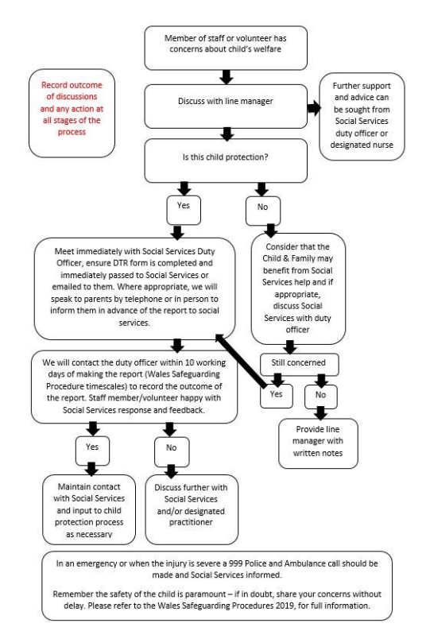

**Appendix 4- Implementation plan**

|  |  |
| --- | --- |
| **Stage** | **Action/ activity required** |
| **Prior to recruitment** | **Sparkle trustees:**   * Sparkle ‘Trustee Recruitment Guidance’ followed |
| **Sparkle hiring managers:**   * Develop clear job descriptions * Include safeguarding references in recruitment materials * Undertake Enhanced DBS (Child barring) * Reference requests * Include questions within all interviews that relate to safeguarding, this should be particularly thorough for roles working directly with children/young people/families * Verify qualifications and experience of candidates * Should have completed safer recruitment training |
| **Sparkle staff members, volunteers and contractors/ partners:**   * Sparkle robust recruitment practices to be adhered to |
| **On commencing with Sparkle** | **Sparkle hiring managers:**   * Place all staff on a probationary period   **All Sparkle trustees, staff members and contractors/ partners:**     * Sparkle Code of Conduct issued * Sparkle Induction plan put in place and followed * Sparkle Policies issued and declaration completed to ensure they have been read and understood (primary safeguarding policies include: Safeguarding and Child Protection, Procedure for Investigating Allegations of Abuse by Members of Staff, Information Security, Putting Things Right; Code of Conduct, Ethical Fundraising, Trustee Recruitment Guidance * Child protection training session offered and completed within 3 months of commencing role * Engage with induction process |
| **Ongoing responsibilities** | **Sparkle Lead safeguarding trustee/ Sparkle safeguarding lead/Head of Operations**   * Ensure policy is up to date * Update policy in response to incidents * Record all incidents of safeguarding and make changes to procedure where necessary * Promote safeguarding within the organisation * Ensure adherence to all Sparkle policies * Act promptly to all concerns from staff * Provide advice and support to staff * Liaise with external agencies * Commit to continuous professional development relating to safeguarding * Run safeguarding sessions for staff and volunteers * Monitor and audit safeguarding practises * Maintain confidentiality * Report appropriately internally and externally * Engage with parents and families   **All Sparkle trustees, staff members and contractors/ partners:**   * Ensuring compliance with responsibilities outlined in the ‘*Sparkle Safeguarding and Child Protection Policy and Procedures’* and the *‘Sparkle Procedure for Investigating Allegations of Abuse by Sparkle Trustees and members of staff’* |