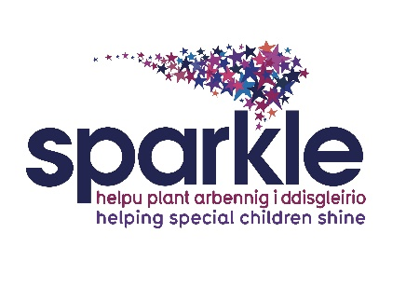

Café / Snack Bar Volunteer

Job Description

Post title: Sparkle volunteer

Responsible to: Sparkle Office Manager

Role Summary
The role of the Café/Snack Bar Volunteer is to provide refreshments to those visiting and working at the centre who wish to use the centre catering facilities.

The volunteer will work alongside other volunteer staff and will liaise with the Sparkle Administrator and report to the centre manager.

Key Tasks
These include but are not exclusive to:

- To provide a warm welcome and friendly, helpful and knowledgeable customer service.

- To be an active and supportive team member, contributing in a constructive manner and treating all Serennu visitors and team members with fairness and courtesy.

- To comply fully with all Health and Safety and Food Hygiene regulations at all times.

Specialist skills/training/ knowledge

- Good knowledge of the food and drink we serve and sell.
- Clear communication with visitors, suppliers and other team members.
- Clean, tidy and appropriate clothing and hair at all times
- Undergo training as required for the role.

Task

- Serving customers promptly, courteously and with a smile.
- Ensuring that food served to customers is of a consistently high standard and well presented.
- Prompt clearance and clearing of tables and area.
- Maintenance of a clean and tidy environment at all times
- Preparing food, as required.
- Assisting in the set up and set down of the café according to procedure on a daily basis or as required.

Person Specification

We are looking for volunteers who:

- Adopt a friendly, happy, welcoming approach
- Have an ability to engage with people of all ages and abilities
- Are outgoing, personable and a good conversationalist
- Have good listening skills
- Display honesty and integrity
- Show compassion and empathy as the situation requires
- Have the ability to make people feel at ease
- Present with a smart, neat appearance and professional demeanour
- Are polite and courteous at all times, regardless of the situation
- Are able to deal calmly with difficult families or visitors
- Are willing to go the extra mile, even at busy times

Disclosure and Barring Service check
This post will result in you having substantial contact with children. By virtue of the Rehabilitation of Offenders Act 1974 (Exceptions) Order 1975, the Children’s Act 1989 and/or the Police Act 1997, you are required to reveal any criminal convictions, bind over orders or cautions, including those which would normally be regarded as spent. You must complete the relevant section on the application form – your application will be returned if this section is incomplete. If successful in your application you will subject to a Disclosure and Barring check to include the children barred list check.

I have received, read and understood this volunteer role description.

Name …………………………………………… (Please print)

Signature ………………………………………………………..

Date ………………………………………………………..

Please return one signed copy to your supervisor at your induction and retain the other for information.

