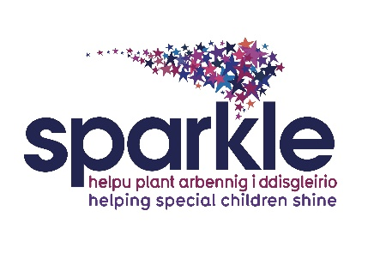

Sparkle Aquatic Helper

Job Description

Post title: Sparkle Aquatic Helper

Responsible to: Sparkle Leisure Team Leader

Location: Crownbridge School, Cwmbran

Rate of pay: National minimum wage – £6.40 (under 18) £8.60 (under 21) £11.44 (over 21)

Hours: Monday 5.45-7.45pm (term time)

Contract Period: Permanent

Job Purpose
To offer assistance to children/young people with disabilities and/or developmental difficulties from within the swimming pool, under the supervision of a swimming teacher. The role may also entail offering support to the swimming teacher in a poolside capacity, by observing the children/young people within the lesson, and also assisting with administration duties.

The role of the Aquatic Helper
- To be a role model
- Assist children and young people in the water that need support, by encouraging them, offering manual support and reassurance.
- Ensure equipment is set up ready for the start of the lesson.
- Assist the swimming teacher in delivering fun, challenging, enjoyable lessons.
- Assist in checking of teaching equipment, ensuring it is fit for purpose. Report any defects in apparatus and equipment to Sparkle Lifeguards or Sparkle Team Leader.

- Treat all children and young people fairly and consistently.
- Ensure professionalism at all times.
- Participate in all necessary external and internal training as required by Sparkle or Aneurin Bevan University Health Board and comply with the requirements of ongoing training in line with your qualification.
- Assist in the promotion of the facility by maintaining a high standard of dress and appearance at all times.
- To volunteer your time on up to 4 days per annum (pro rata) for the purposes of running or assisting in Sparkle Fun Days or similar.

- Undertake any other duties, commensurate with the grade of the post, as directed by the Sparkle Leisure Team Leader.
Management Responsibilities
No management responsibilities

Responsible to
Sparkle Leisure Team Leader

Special Conditions
This job requires a satisfactory DBS check, children barred list check and occupational health check. Two satisfactory references are also required as is proof of identification and authorisation to work in the UK.
Disclosure and Barring Service check
This post will result in you having substantial contact with children. By virtue of the Rehabilitation of Offenders Act 1974 (Exceptions) Order 1975, the Children’s Act 1989 and/or the Police Act 1997, you are required to reveal any criminal convictions, bind over orders or cautions, including those which would normally be regarded as spent. You must complete the relevant section on the application form – your application will be returned if this section is incomplete. If successful in your application you will subject to a Disclosure and Barring check to include the children barred list check.

Person Specification
 | Essential | Desirable | Indicated by
Experience |  | Experience of working in a leisure facility  Working with Children and Young People with a disability or developmental difficulty and their families | Application Form & Interviews
Knowledge | Knowledge of swimming and swimming techniques that are taught to help participants |  | Application Form & Interviews
Professional Skills | Ability to interact with children & young people  Establish good working relationships with staff and volunteers  Are able to adapt quickly and flexibly to situations to ensure the smooth running of sessions should unexpected events occur  Are polite and courteous at all times, regardless of the situation |  | Application Form, Interviews & references
Personal  Attributes | Motivated  Adopt a friendly, happy, welcoming approach  Approachable  Excellent communication skills  Reliable and committed  Organised  Able to work as part of a team  Show empathy, patience and understanding |  | Application Form, Interviews & references

